NIZAN MAKEOVERS — FULL WEBSITE CONTENT

NAVIGATION
- About Us
- Services
- Our Works
- Our Team
- Contact
- [BOOK NOW]

Luxury bridal makeup artist

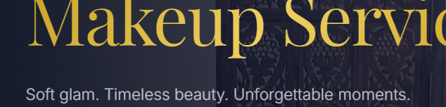
Turning your dream bridal look into reality

Nizan Makeovers is one of Kerala’s leading luxury bridal makeup studios, founded by Feeniya Nizan, a renowned bridal makeup artist in India. Known for expert Airbrush and Signature Makeup, the studio has beautifully transformed over 2,000 brides across India and the UAE.

About US

Nizan Makeovers is a top celebrity makeup artist in Kerala, founded by Feeniya Nizan, a leading professional makeup artist. We specialize in bridal makeup, wedding makeup, and celebrity beauty services.
As a trusted bridal makeup artist and bridal makeup specialist, we offer premium bridal makeup services, including celebrity makeup and customized bridal looks. Our expertise in Airbrush and Signature Makeup ensures flawless, long-lasting results.
If you are looking for a bridal makeup artist in Kerala, Nizan Makeovers delivers a luxury beauty experience with perfection and elegance.
Nizan Makeovers is also the parent company of Team N Makeovers, a fast-growing beauty brand across Kerala and Tamil Nadu. Together, we continue to set high standards in the industry through expert services, strong team presence, and professional excellence.
Our specialities:
Hindu Bridal Makeup
Christian Bridal Makeup
Muslim Bridal Makeup
Celebrity Makeup
Masterclass – India & UAE

2000+ bridal transformation
8+ years of experience
10 + Masterclasses

What We Offer
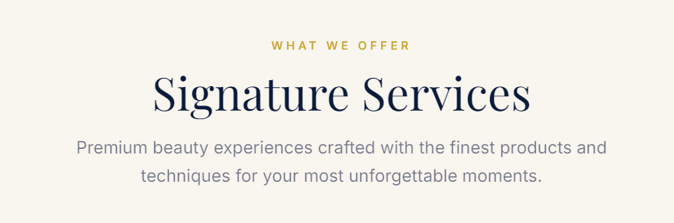
Signature Services
We use only the world's finest, dermatologically trusted, luxury-grade products — because you deserve beauty that is as immaculate as the moment itself.
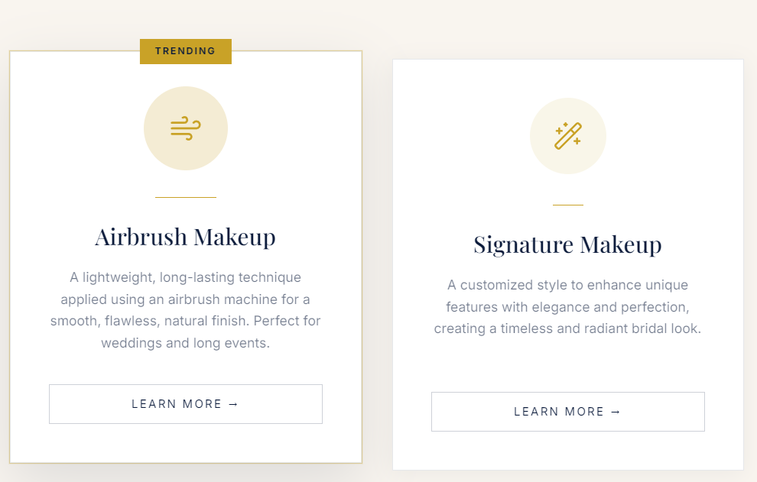
Airbrush Makeup: same content
Signature Makeup:
Our Signature Makeup is a premium, customized service by a professional makeup artist, designed to enhance your natural beauty with elegance and precision. As a trusted bridal makeup artist and bridal makeup specialist, we create flawless, long-lasting bridal makeup and radiant, timeless bridal looks

Meet Our Team

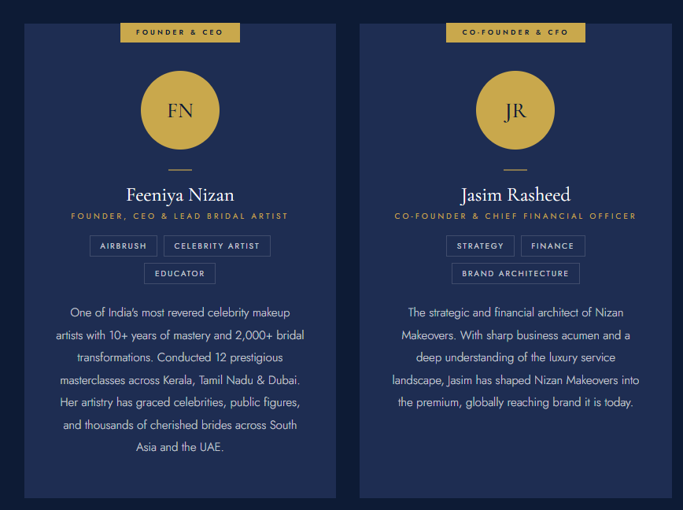

Founder & CEO
- Feeniya Nizan
Founder, CEO & Lead Bridal Artist
Airbrush | Celebrity Artist | Educator
One of India's most revered celebrity makeup artists with 10+ years of mastery and 2,000+ bridal transformations. Conducted 12 prestigious masterclasses across Kerala, Tamil Nadu & Dubai. Her artistry has graced celebrities, public figures, and thousands of cherished brides across South Asia and the UAE.

Co-Founder & CFO
- Jasim Rasheed
Co-Founder & Chief Financial Officer
Strategy | Finance | Brand Architecture
The strategic and financial architect of Nizan Makeovers. With sharp business acumen and a deep understanding of the luxury service landscape, Jasim has shaped Nizan Makeovers into the premium, globally reaching brand it is today.

Why Choose Nizan
THE NIZAN DIFFERENCE
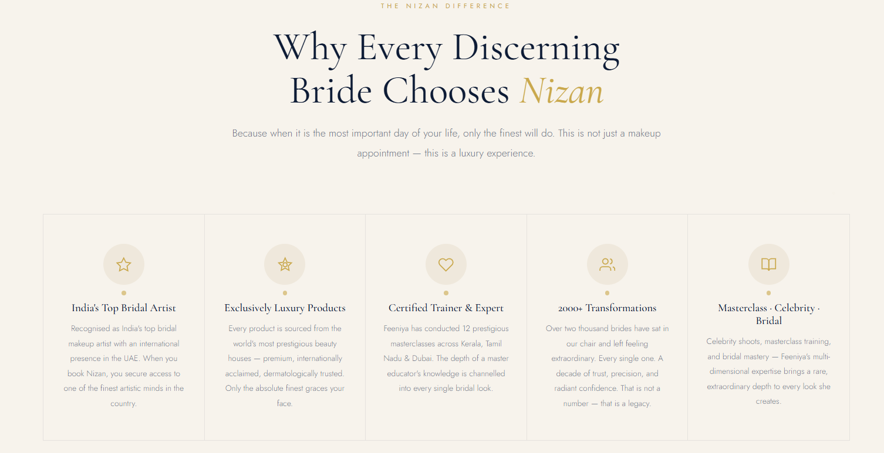
Uncompromising quality and unparalleled expertise in every brushstroke, every look, every moment.

India's Top Bridal Artist
Recognised as India's top bridal makeup artist with an international presence in the UAE. When you book Nizan, your secure access to one of the finest artistic minds in the country.
Exclusively Luxury Products
Every product is sourced from the world's most prestigious beauty houses — premium, internationally acclaimed, dermatologically trusted. Only the absolute finest graces your face.
Certified Trainer & Expert
Feeniya has conducted 10+ prestigious masterclasses across Kerala, Tamil Nadu & Dubai. The depth of a master educator's knowledge is channelled into every single bridal look.
2000+ Transformations
Over two thousand brides have sat in our chair and left feeling extraordinary. Every single one. A decade of trust, precision, and radiant confidence. That is not a number — that is a legacy.
Masterclass · Celebrity · Bridal
Celebrity shoots, masterclass training, and bridal mastery — Feeniya's multi-dimensional expertise brings a rare, extraordinary depth to every look she creates.

Your Most Beautiful Moment Awaits

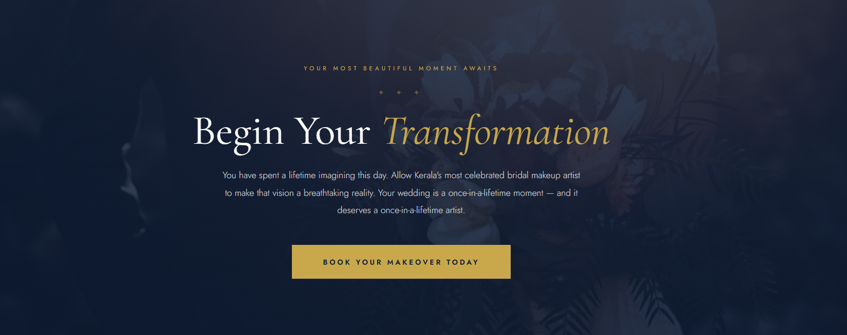
Begin Your Transformation
Book your consultation with a bridal makeup artist and experience premium bridal makeup services with the best makeup artist in Kerala.

Book Your Makeover Today

GET IN TOUCH
Contact Us
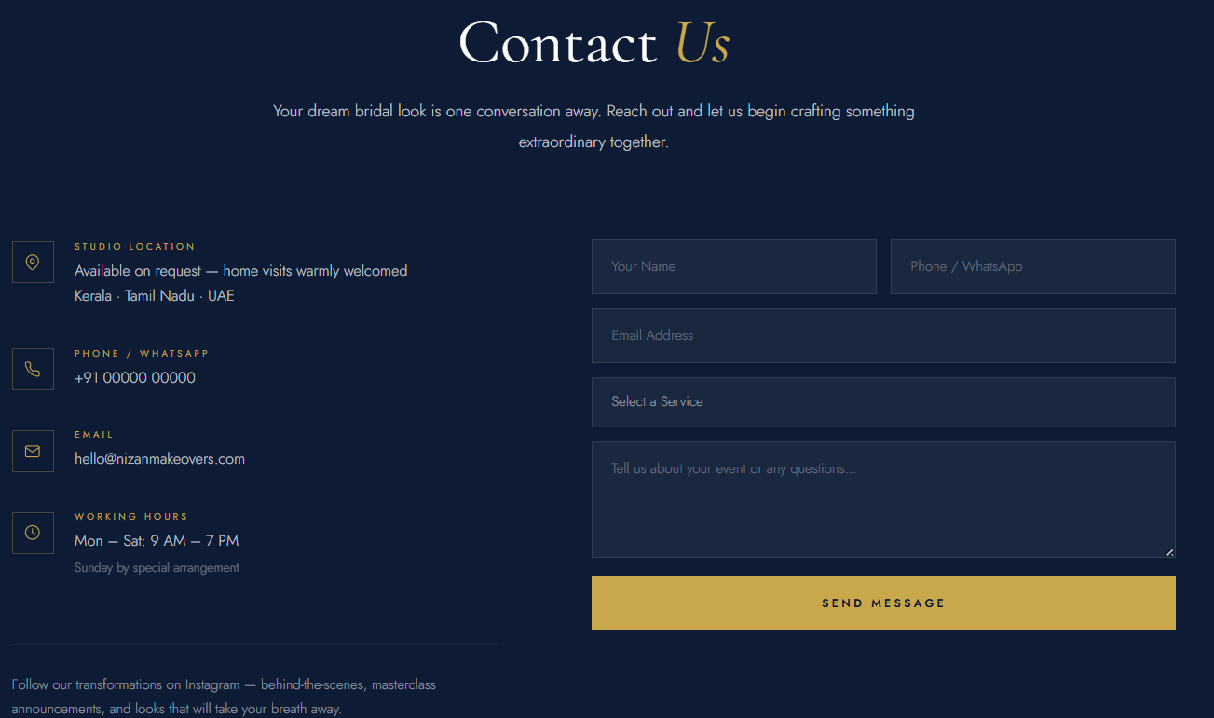

Have a question or ready to book? Reach out and we'll get back to you promptly.

Studio Location
Available on request — home visits warmly welcomed
India · UAE · Malaysia
PHONE / WHATSAPP
+91 97465 14181
EMAIL
nizanmakeovers@gmail.com

Working Hours
Always Open

Follow our transformations on Instagram -- masterclass announcements, behind-the-scenes and stay updated with the latest looks, tips, and exclusive offers.

Instagram: https://www.instagram.com/nizanmakeovers?utm_source=ig_web_button_share_sheet&igsh=ZDNlZDc0MzIxNw==

Facebook:
https://www.facebook.com/nizanmakeover

YouTube:
https://www.youtube.com/@nizanmakeovers

